**Chippenham Tennis Club**

**Treasurer’s Report**

**Year ended 31 August 2021**

**Executive summary**

Despite a second year where life was impacted by COVID19 and lockdowns, financially 2020/21 was a year of cautious financial stability for the club. With the background of the global pandemic and the uncertainty that this created for the club and its members, the Committee chose to reduce the price of annual subscriptions from the pre-pandemic levels, take cautious approach to expenditure, and defer investment in major development projects. As a result, the Club’s financial assets have increased by £7,527 to a healthy £53,121 and, assuming that membership numbers continue at similar levels, this financial position should enable the club to fund future lighting and court maintenance / improvement projects when required.

**Total Income**



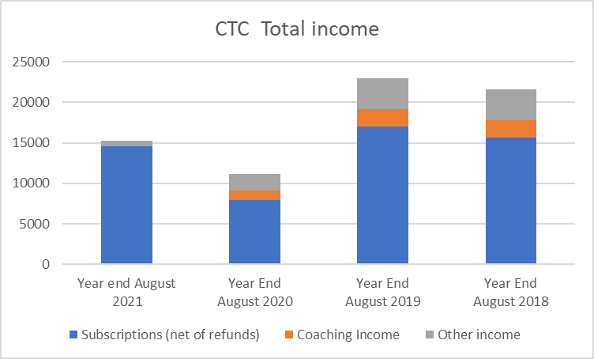

Subscriptions

With tennis courts allowed to re-open in March and the increased appeal of outdoor sport – the club has seen an increase in membership numbers in 2021. And these higher membership numbers have largely offset the reduction in annual subscription pricing – subscriptions for 2021 were £14,561 (2020: £7,946) – and subscriptions have recovered to 85% of the pre-pandemic levels achieved in 2019 (£17,055).

Other income

Other income was negatively impacted by lower activity levels that can be mainly linked to the pandemic. No coaching income was generated in 2021 – in comparison the Club earned £2,100 in 2019 from this source. As winter tennis competitions were curtailed and as the majority of summer match fees have not yet been collected there has been a low level of match fees income during the last 12 months – but this should increase in 2021/22. Income from other sources (visitors, court hire, etc) were also reduced, but floodlight income increased as the cash that had accumulated in the floodlight boxes was banked during the period.

**Expenditure**



With no major capital projects undertaken during the year, and a cautious approach to expenditure, the Club’s outgoings for 2021 were relatively low at only £7,695.

The tennis section has contributed to the continued existence of the Sports Club by continuing to pay the full subscriptions during the last 2 years. For 2021 the Tennis Club’s subscriptions to the Sport Club increased by £1,300 (+39%) to £4,667 (2020: £3,367) as a result of higher membership numbers. This is the Club’s main operating cost – with 32% of membership fees being passed to the Sports Club (17% in 2019, 22% in 2018) – the increased % is a reflection of the lower annual tennis club subscription prices, rather than a significant change to the amount paid per member to the Sports Club.

In 2021 there was a small increase in LTA Affliation fees to £720, but Coaching section payments were reduced to £1,330. As there was stock of tennis balls left over from 2020 and less tennis played during part of the year, the expenditure on tennis balls was reduced from previous years – but this is expected increase to earlier levels in 2021/22. The Club did not make any charitable donations, incurred very low other/general expenses, and had no major court / development expenditure during the year.

Analysis of Club’s investments during the year :

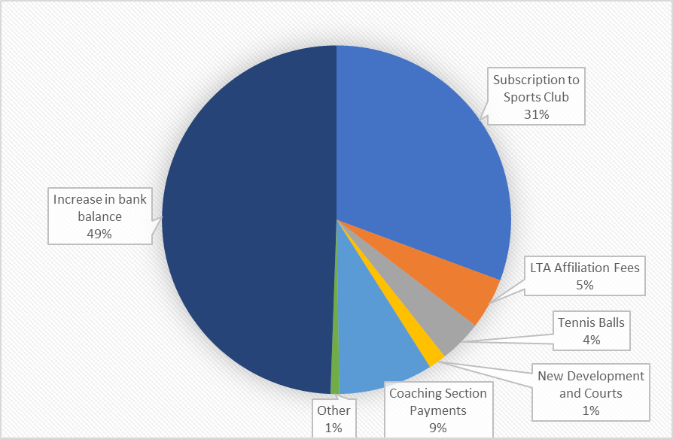

As a result of an increase in income and no major capital project expenditure, the Club has increased it bank balance by £7,527 during the year – with almost 50% of total income being retained for future investment requirements.

**Balance of accounts at the year end**

|  |  |  |
| --- | --- | --- |
|  | **31/08/2021** | **31/08/2020** |
| Cheque Account | £17,994.69 | £10,471.18 |
|  |  |  |
| Sinking Fund Account | £34,995.47 | £34,991.98 |
| Cash in Hand | £131.00 | £131.00 |
| **Total** | **£53,121.16** | **£45,594.16** |
|  |  |  |
| **Change in funds during the year** | **£7,527.00** |  |

The balance at the year end is £53,121 – a return to growth with an increase of £7,527 (2020: a decrease in funds of £9,510). With this year end balance the Club is in a secure financial position, able to meet any expected liabilities as they fall due, and able to consider future capital investments to maintain and further improve the courts and facilities.

Dean Cooke

Chippenham Tennis Club Treasurer

Appendix

